**1)Empty dynamoDB table created with primary key id**  
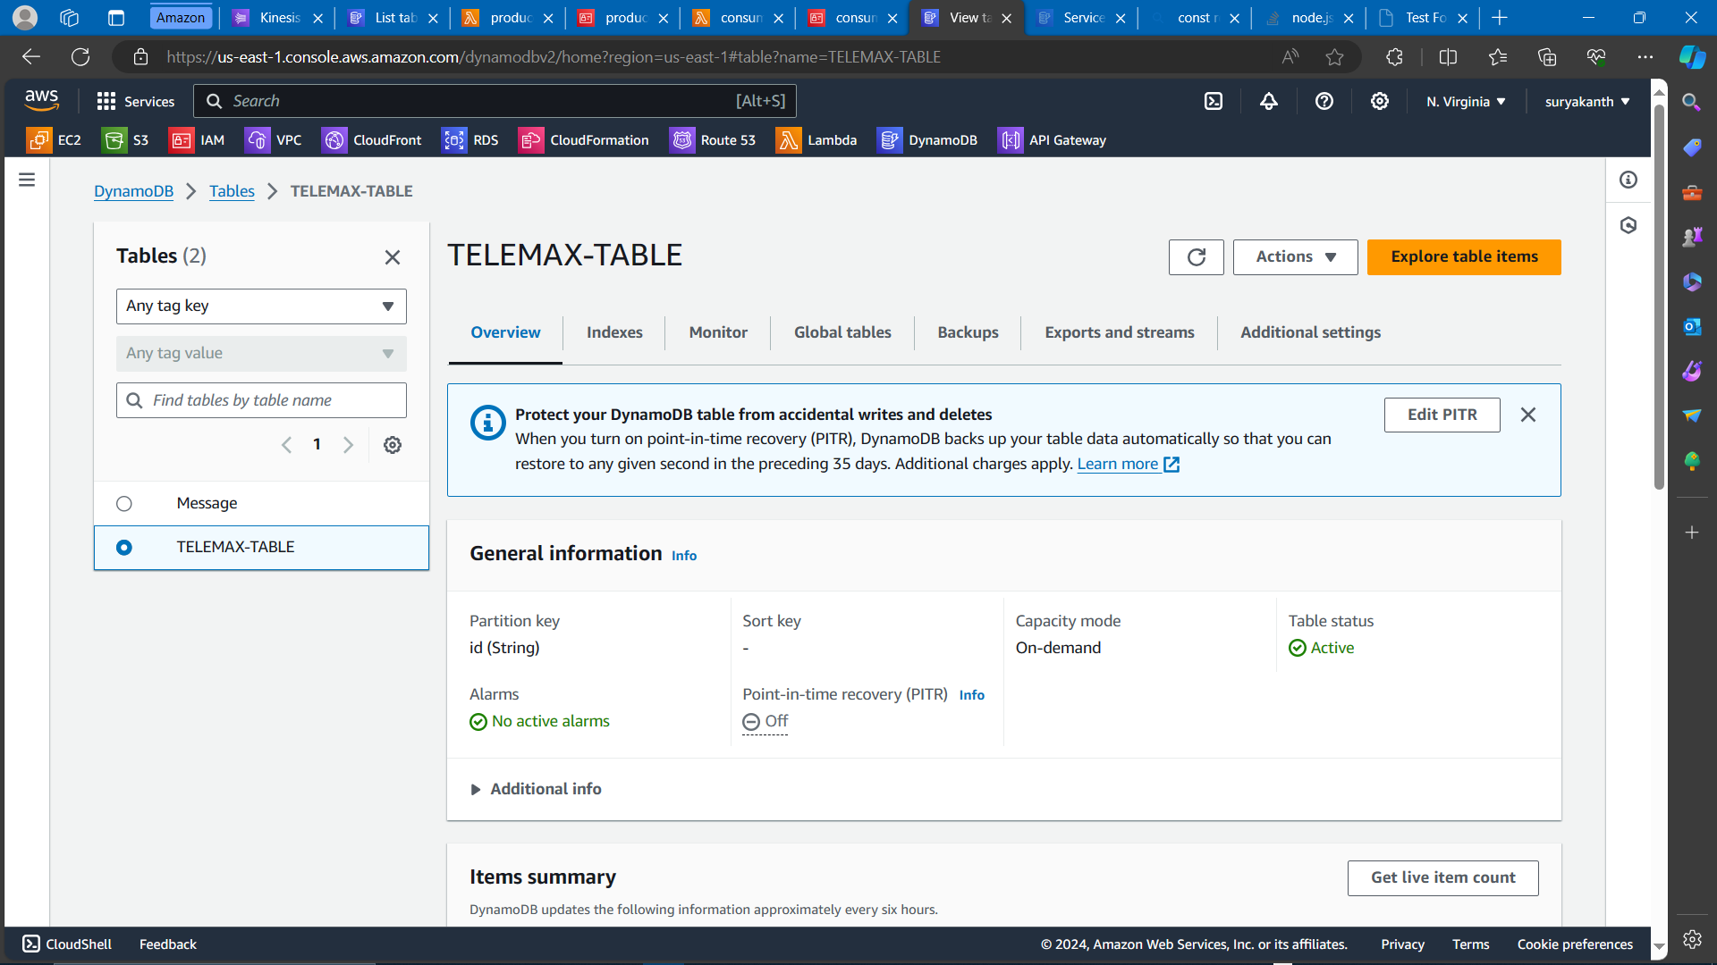

**2) Producer lambda function to send data to Kinesis Datastream**  
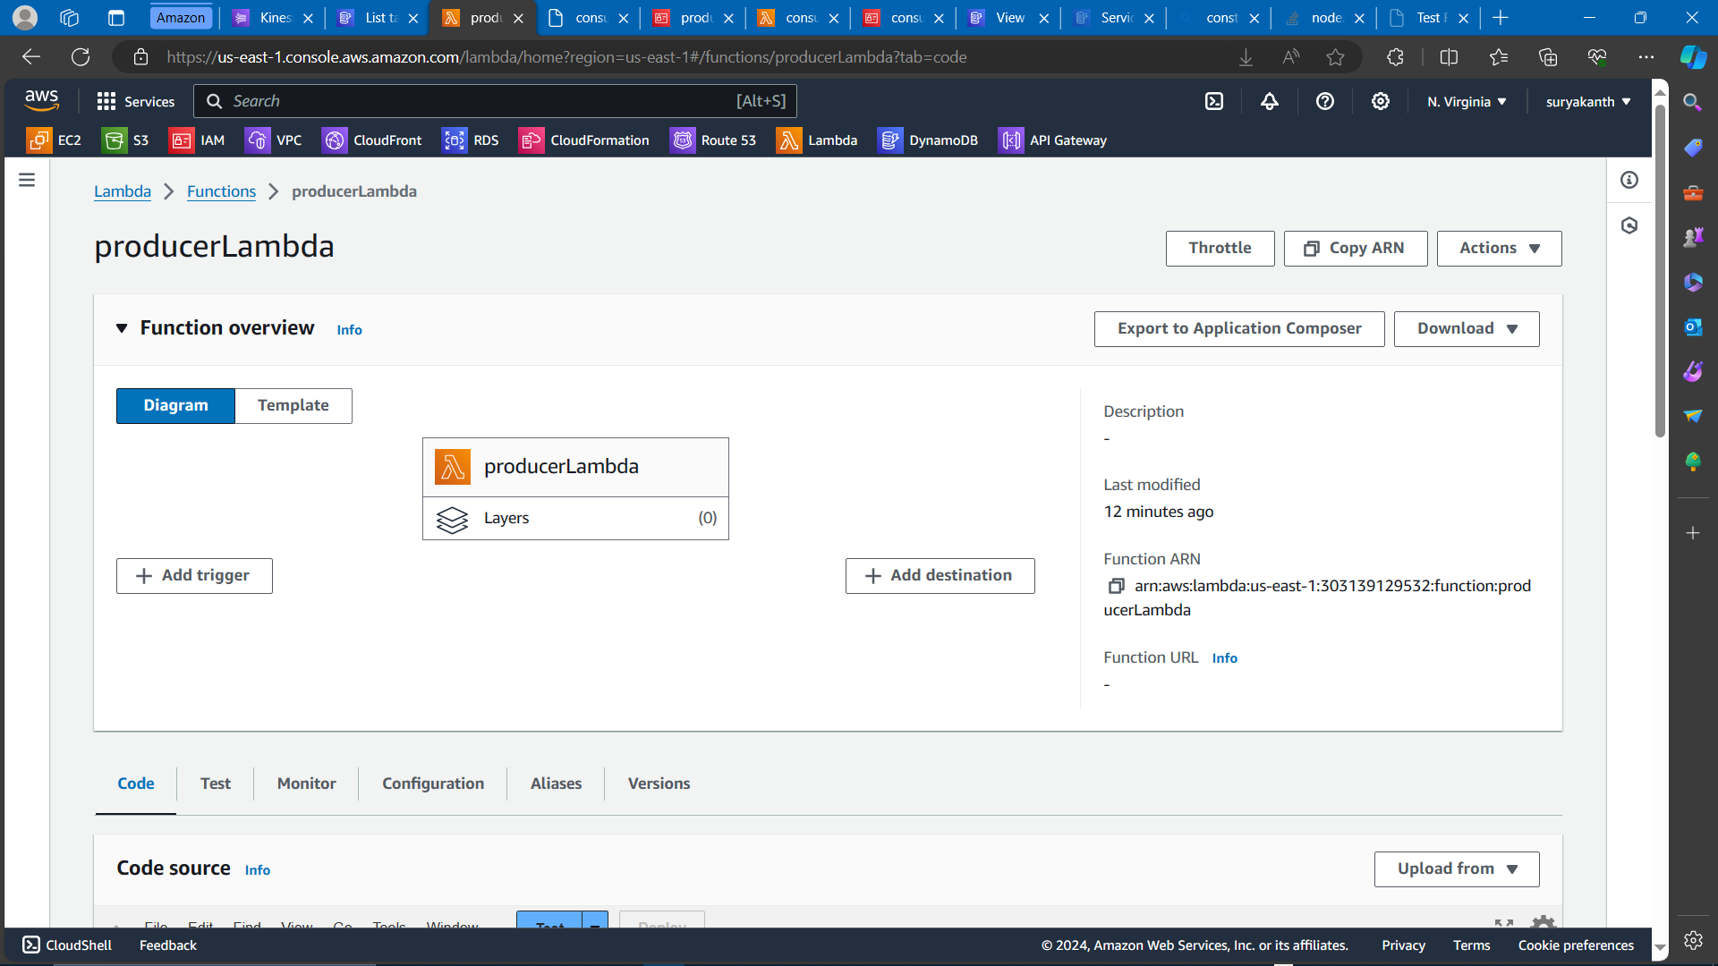  
  
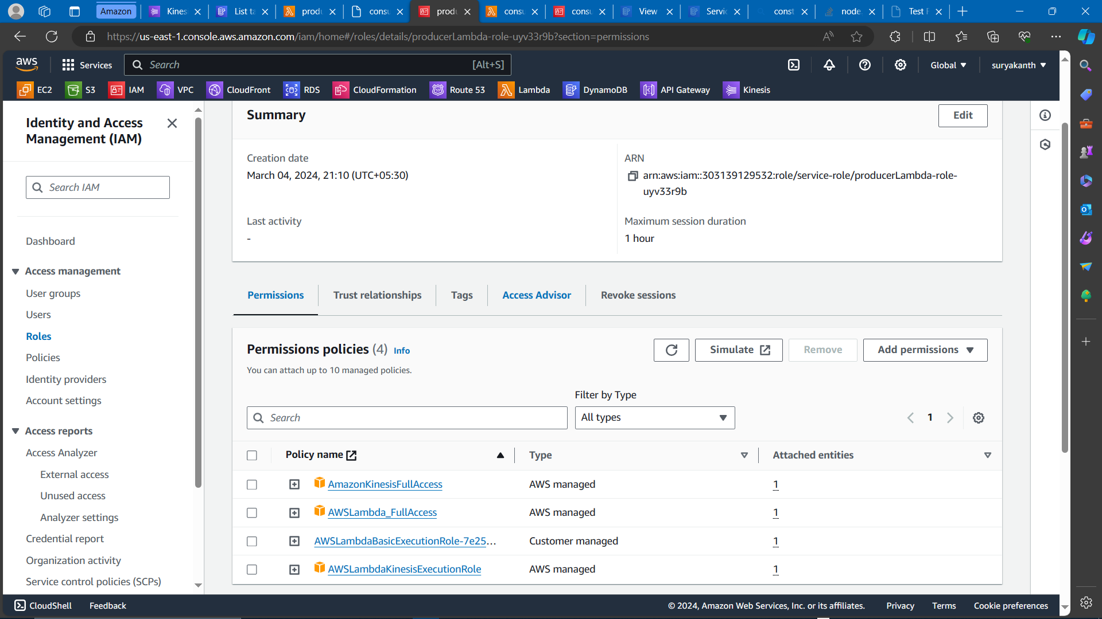  
  
**3) Consumer lambda function to create data in dynamoDB table from Kinesis Datastream**  
  
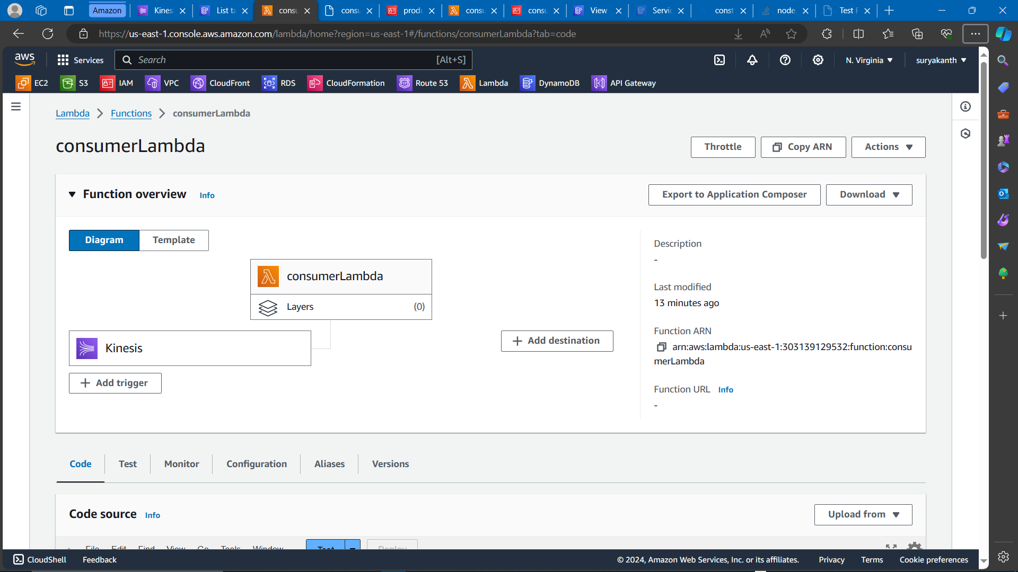  
  
  
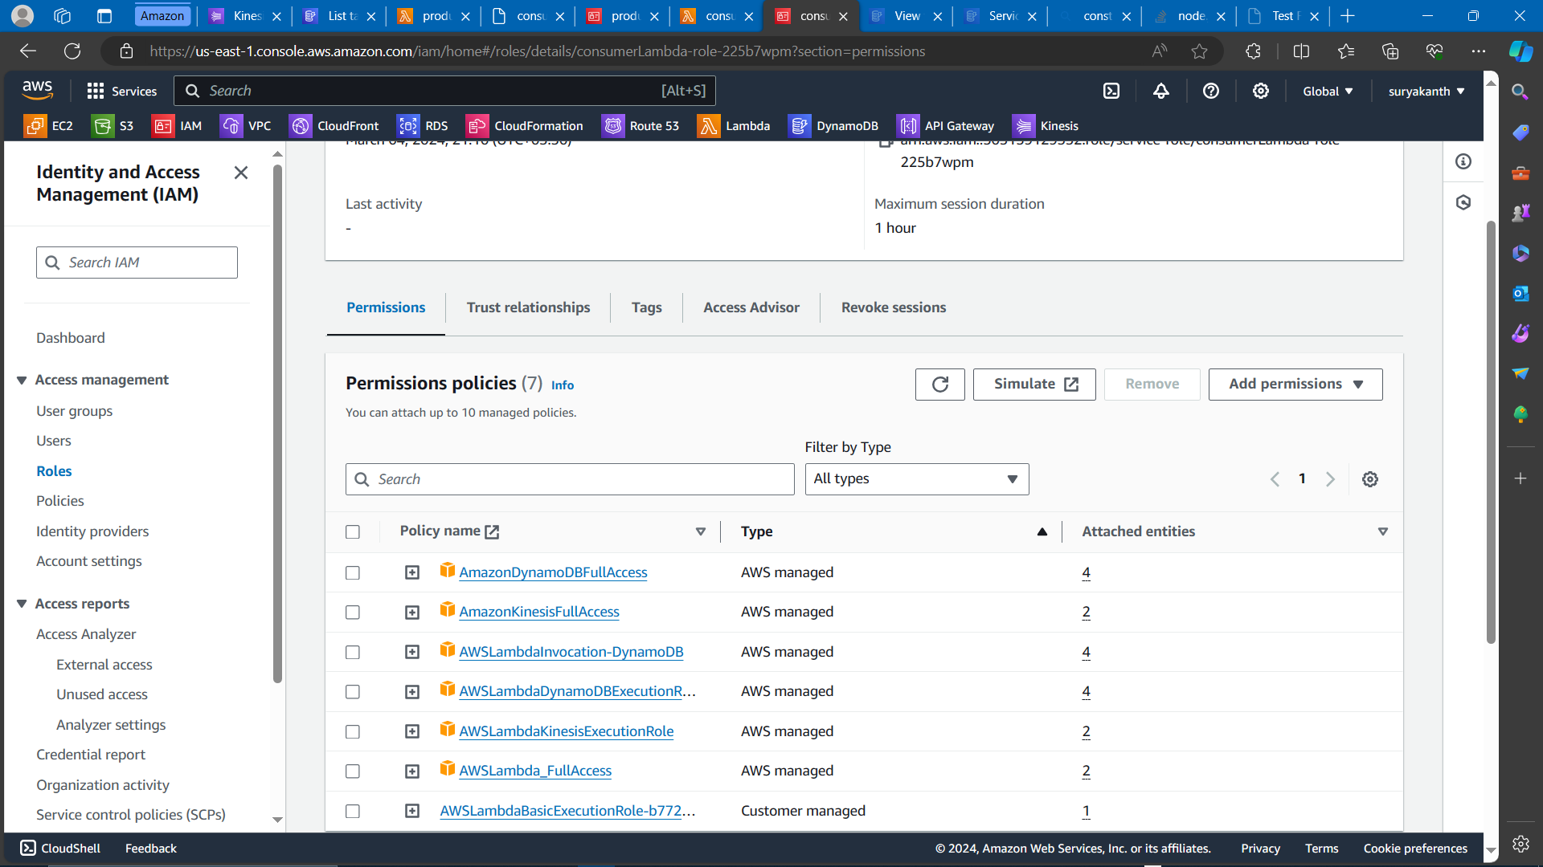  
  
**4) Kinesis data stream which triggers consumer lambda function**  
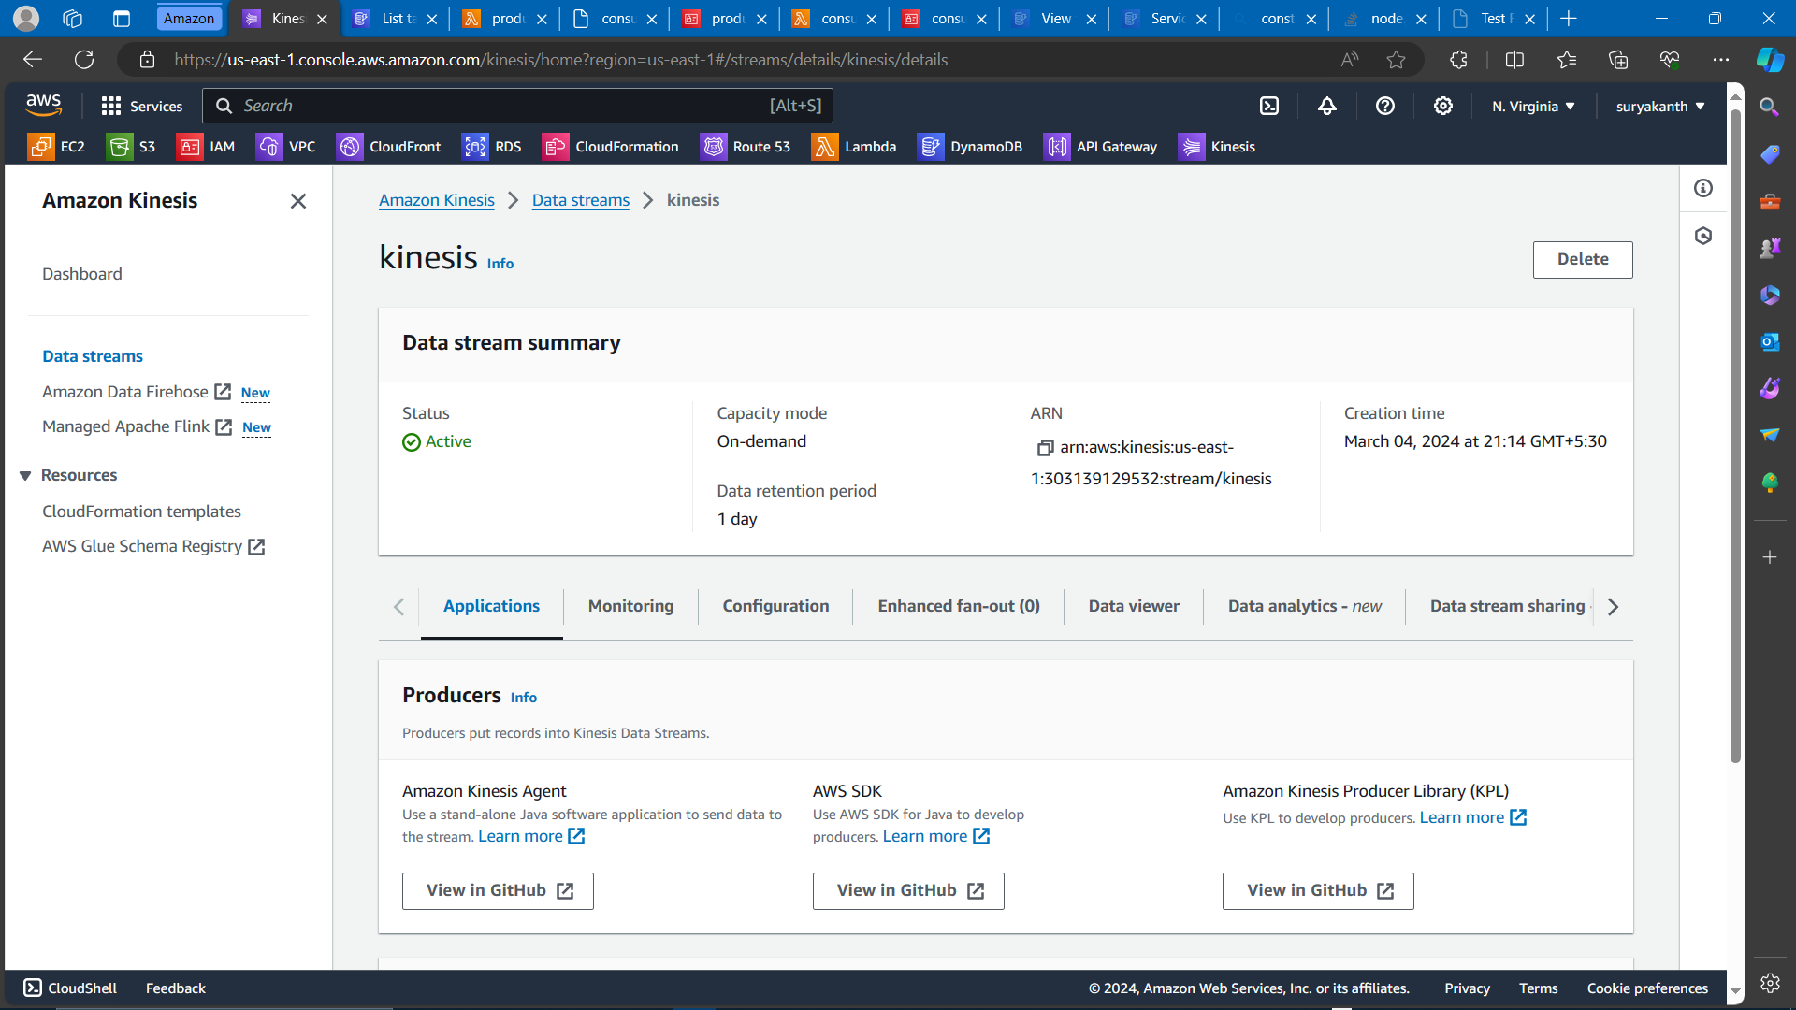  
  
  
  
  
  
**5) Kinesis data stream which triggers consumer lambda function**  
  
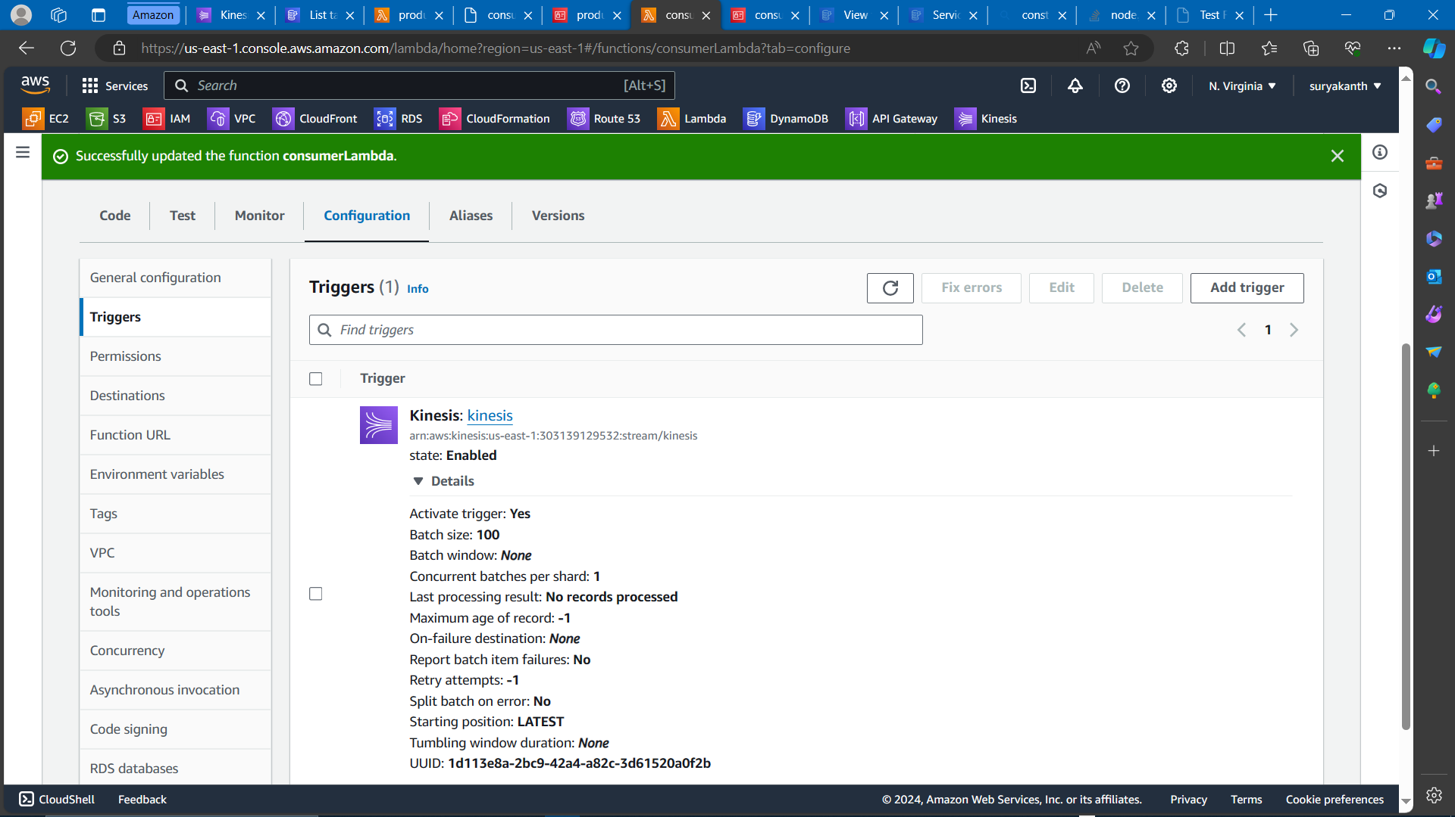  
  
**6) Testing producer lambda function with sample data**  
  
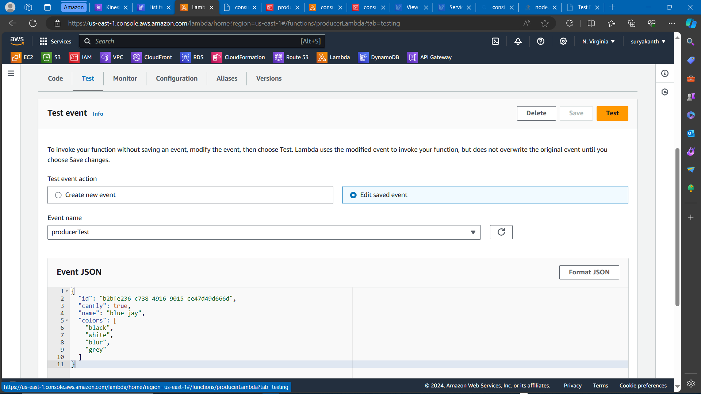  
  
  
**7) Sample data saved in dynamoDB table**  
